From: <https://matthewehret.substack.com/p/might-syria-become-a-gateway-of-the>

Might Syria Become A Gateway Of The New Silk Road With Assad-Xi Summit?

Author: MATTHEW EHRET

Date: SEP 22, 2023

[[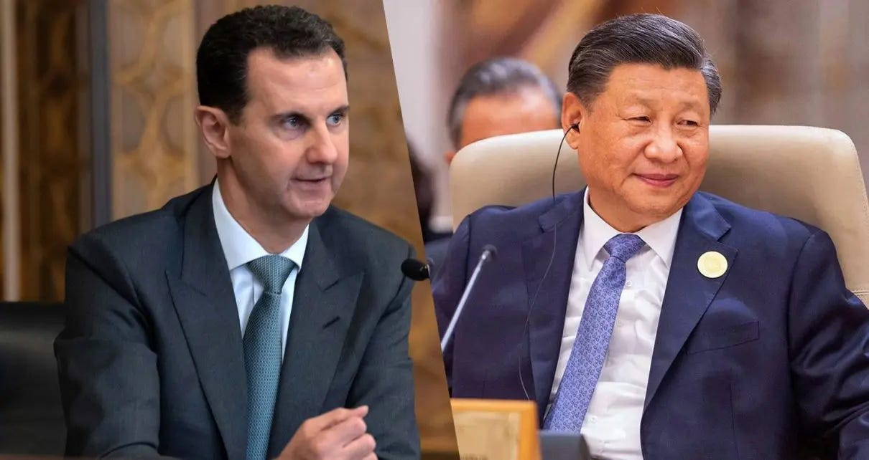](https://substackcdn.com/image/fetch/f_auto,q_auto:good,fl_progressive:steep/https:/substack-post-media.s3.amazonaws.com/public/images/4a89f688-a315-435f-9b3f-7bd63ff30402_1210x642.webp)](https://substackcdn.com/image/fetch/f_auto,q_auto:good,fl_progressive:steep/https%3A%2F%2Fsubstack-post-media.s3.amazonaws.com%2Fpublic%2Fimages%2F4a89f688-a315-435f-9b3f-7bd63ff30402_1210x642.webp" \t "_blank)

#### [Originally published on The Last American Vagabond](https://www.thelastamericanvagabond.com/syria-gateway-new-silk-road-assad/)

##### *****On September 21st,*****[*President Bashar al Assad will be visiting Beijing on the direct invitation of President Xi Jinping*](https://www.presstv.ir/Detail/2023/09/19/711129/Assad-China-Visit-Help-Syria-Reconstruction-Nullifying-Sanctions)*****and will be accompanied by a large economic delegation where the discussion of Syrian re-construction and integration into the Belt and Road initiative will be high on the agenda.*****

Ever since President Bashar al-Assad first announced [the Five Seas vision](https://archive.schillerinstitute.com/educ/hist/2015/1113-assad_5_seas.html) in 2004 as a response to the newly virulent regime change operation launched in the wake of 9/11, the battle lines have been clearly drawn over two opposing destinies shaping the Arab world. When the western-directed Arab Spring of color revolutions sabotaged the efforts of the Five Seas program (and also broader Libyan plans for a Great Manmade water project funded by a gold backed Dinar), things took a very dark turn. This shouldn’t have been a surprise for anyone familiar with [U.S General Wesley Clark](https://en.wikipedia.org/wiki/Wesley_Clark)’s October 2007 exposure of the neo-con agenda to burn the Middle East with a focus on Iraq, Libya, Iran, and Syria:

[Mandatory to see 8min10sec:] [Wesley Clark October 3 2007 Commonwealth Club of California](https://www.youtube.com/watch?v=TY2DKzastu8&t=14s) <https://www.youtube.com/watch?v=TY2DKzastu8&t=14s>

NATO military interventions demolished [Libya](https://www.thelastamericanvagabond.com/libya-death-toll-natos-fault/) and threatened to replicate itself in Syria with a weaponized [Al-Qaeda managed by the CIA](https://www.thelastamericanvagabond.com/secret-history-alqaeda-1/), MI6 ([via the White Helmet operation](https://www.mintpressnews.com/white-helmets-terror-syria/231597/)), and Turkish/Saudi proxies to carry out the first phase of this scorched earth program.

But with the possibility for a new economic architecture based on large scale development, industrial growth, and peace deals between partner states made possible by the Belt and Road Initiative (BRI) (launched in 2013), and having miraculously defended herself from a ten year military onslaught, Syria is hungry to rebuild and potentially revive her ancient role as pearl along the ancient Silk Road.

Of course, the pain and destruction of the war is still deeply felt; illegal US sanctions continue to plague the hungry masses, prevent the reconstruction of basic infrastructure and access to potable water, and cripple schools, hospitals, businesses, and livelihoods.

[[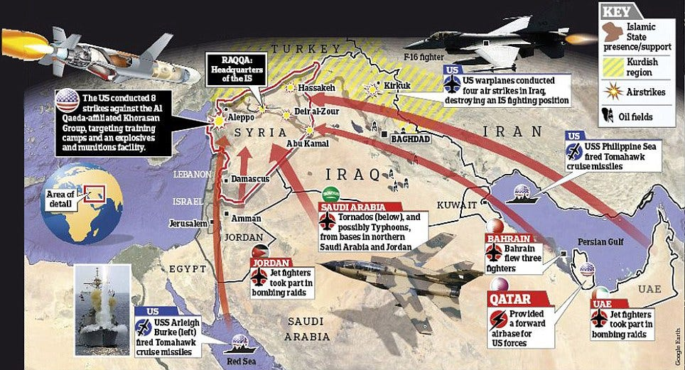](https://substackcdn.com/image/fetch/f_auto,q_auto:good,fl_progressive:steep/https:/substack-post-media.s3.amazonaws.com/public/images/1ebaaf23-18e9-415b-86d1-8a09aaf7dff5_964x521.jpeg)](https://substackcdn.com/image/fetch/f_auto,q_auto:good,fl_progressive:steep/https%3A%2F%2Fsubstack-post-media.s3.amazonaws.com%2Fpublic%2Fimages%2F1ebaaf23-18e9-415b-86d1-8a09aaf7dff5_964x521.jpeg" \t "_blank)

### ****The BRI And Syria’s New Future****

[On 5 November 2021,](https://www.chinadaily.com.cn/a/202111/05/WS61850aaea310cdd39bc73a56.html) China’s President Xi Jinping spoke with Syrian President Bashar Al-Assad, saying “we welcome the Syrian side’s participation in the Belt and Road Initiative and Global Development Initiative” and calling for reconstruction, development, and the defense of Syria’s sovereignty and territorial integrity.

The discussion came in the wake of Chinese Foreign Minister Wang Yi’s [whirlwind tour](https://journal-neo.org/2021/07/27/wang-yi-s-tour-of-the-greater-middle-east/) across West Asia and North Africa in July 2021, during which he met the Arab League’s chief to discuss Syria’s return to the fold.

By the end of this tour – which coincided with Assad’s re-election – China had signed a [four-point proposal](http://www.xinhuanet.com/english/2021-07/18/c_1310067701.htm) for solving Syria’s multifaceted crisis with a focus on large scale reconstruction, ending illegal sanctions, and respecting Syria’s sovereignty.

Syria, in turn, re-affirmed its support for China’s territorial integrity in the face of western-sponsored separatist movements in Xinjiang, Tibet, Taiwan, and Hong Kong.

China’s interest in West Asian development was first made known in 2017 when Chinese foreign ministry spokesman Geng Shuang stated:

“Too many people in the Middle East are suffering at the brutal hands of terrorists. We support regional countries in forming synergy, consolidating the momentum of anti-terrorism and striving to restore regional stability and order. We support countries in the region in exploring a development path suited to their national conditions and are ready to share governance experience and jointly build the Belt and Road and promote peace and stability through common development.”

In 2018, China offered $28 billion in development aid to Syria while simultaneously coordinating the integration of Iraq into the BRI, made official in September 2019 when then-Prime Minister Adil Abdul Mahdi unveiled the [China-Iraq oil-for-reconstruction program](https://www.al-monitor.com/originals/2019/10/iraq-china-india-oil-construction.html) and Iraq’s broader integration into the BRI framework.

Events coordinated by foreign interests did not permit this momentum for long. Mass protests soon toppled Abdul Mahdi’s government and, with it, the oil-for-reconstruction initiative. While recent months have seen a revival of this initiative from Iraq in piecemeal form, progress has been slow.

Instead, the 25 year [Comprehensive Strategic Partnership](https://www.president.ir/EN/91435) agreement struck between China and Iran in March 2021 has become the main gateway for extending Beijing’s infrastructure and connectivity projects into West Asia.

The construction of the Iran–Iraq Shalamcheh-Basra rail line is [now underway](https://www.thenationalnews.com/mena/iraq/iraq-and-iran-close-in-on-deal-to-build-cross-border-railway-1.1225177), bringing the two neighboring states into an equal cooperative footing and opening prospects for greater rail and energy corridors extending from Iran through Iraq and into Syria, as a southern branch of the BRI.

In April 2019, Syria was invited to attend the first official BRI summit in Beijing, where President Assad [stated](https://www.silkroadbriefing.com/news/2019/12/17/syria-reaches-join-chinas-belt-road-initiative/):

“We have proposed around six projects to the Chinese government in line with the Belt and Road methodology and we are waiting to hear which project, or projects, will be in line with their thinking … I think when this infrastructure is developed, with time, the Silk Road (Belt and Road Initiative) passing through Syria becomes a foregone conclusion, because it is not a road you only draw on a map.”

So what, specifically, are those projects?

China and Syria are keeping their cards close to their chest when it comes to details for the moment. But it is not impossible to make some educated guesses about Assad’s wish-list by revisiting his earlier strategic vision for Syria.

Specifically, that would be the Five Seas Strategy that Assad had championed from 2004 to 2011, which disappeared from view once Syria was targeted for destruction.

### ****The Five Seas Strategy, In Brief****

The Five Seas strategy involves the construction of rail, roads, and energy grids connecting the water systems of the

1. Mediterranean,
2. Persian Gulf,
3. Black Sea,
4. Red Sea, and
5. Caspian Sea

with Syria. The project serves as a logical node uniting the diverse nations of [Mackinder’s world island](https://thediplomat.com/2019/01/china-and-the-world-island/) behind a program of harmonization, integration and win-win industrial cooperation.

In a 2009 interview, President Assad [described this project](https://www.fdd.org/analysis/2010/06/29/a-syria-in-minor-key/) passionately:

“Once the economic space between Syria, Turkey, Iraq and Iran becomes integrated, we would link the Mediterranean, Caspian, Black Sea, and the [Persian] Gulf . . . we aren’t just important in the Middle East . . . Once we link these four seas, we become the unavoidable intersection of the whole world in investment, transport, and more.”

These weren’t empty words. By 2011, Assad had led delegations and signed agreements with Turkey, Romania, Ukraine, Azerbaijan, Iran, Iraq, and Lebanon to begin the Five Seas projects. This was done at a time when Libya’s President Qaddafi was well underway in building the [Great Man-Made River](https://en.wikipedia.org/wiki/Great_Man-Made_River), the largest water project in history alongside a coalition of nations that included Sudan, Ethiopia, and Egypt.

[[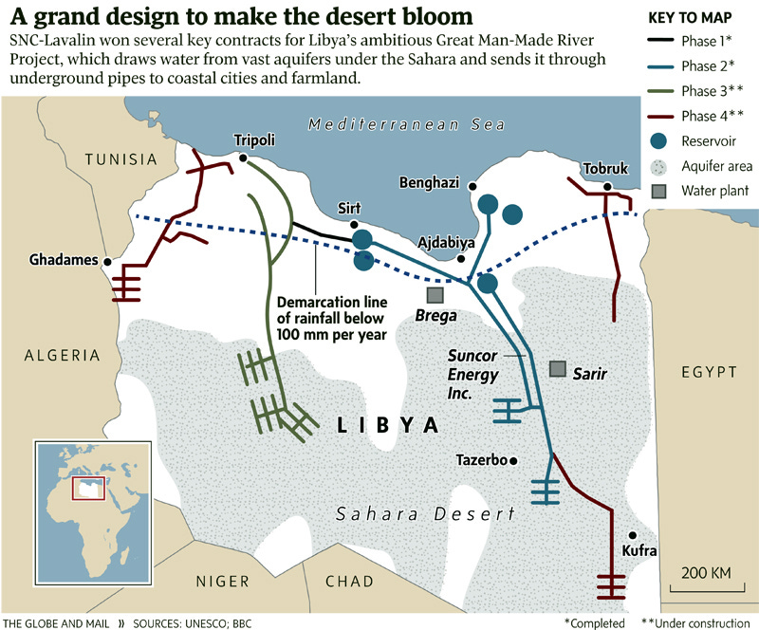](https://substackcdn.com/image/fetch/f_auto,q_auto:good,fl_progressive:steep/https:/substack-post-media.s3.amazonaws.com/public/images/5159ea24-1af4-4843-a762-94bc07285d32_800x664.jpeg)](https://substackcdn.com/image/fetch/f_auto,q_auto:good,fl_progressive:steep/https%3A%2F%2Fsubstack-post-media.s3.amazonaws.com%2Fpublic%2Fimages%2F5159ea24-1af4-4843-a762-94bc07285d32_800x664.jpeg" \t "_blank)

The true reasons for

* Qaddafi’s killing,
* the carving up of Sudan in 2009, and
* the current efforts at US-sponsored regime change in Ethiopia

cannot be comprehended without an understanding of this potent, game-changing strategic paradigm that he and others were spearheading.

### ****The Need For Secrecy****

The secrecy of Chinese-West Asian diplomacy in the emerging post-regime-change world now emerging should therefore be understood as an obvious **necessity**.

For the past decade, every time a West Asian or African nation makes a public announcement of a BRI-compatible program, that same nation has been promptly dragged through different degrees of foreign sabotage. Neither Assad nor the Chinese have any intention to replay that trend at this pivotal moment.

Soon after the heads of Syrian and Turkish intelligence agencies [met in Baghdad in](https://en.mehrnews.com/news/178255/Senior-Turkish-Syrian-intelligence-chiefs-to-meet-in-Baghdad) early September, Assad [reportedly told](https://asiatimes.com/2021/09/secret-syria-talks-speak-to-a-post-us-middle-east-era/) a Lebanese delegation that “many Arab and non-Arab states **are communicating with us, but asking us to keep this a secret**.”

The nature of this secret diplomacy soon became clear, when the Arab League made its [May 23, 2023 re-admission of Syria into the fold](https://edition.cnn.com/2023/05/07/middleeast/arab-league-readmits-syria-intl/index.html) and admitted that the 2011 expulsion of Syria was a strategic error instigated by western imperialists.

Former sworn enemies of Bashar Assad, such as the UAE and Saudi Arabia, have demonstrated their willingness to accept their humiliation, recognize Assad’s legitimacy, and adapt to a new set of rules of the great game more in harmony with their actual self-interests. Both Saudi Arabia and the UAE decided to join the BRICS+ in January 2024 (along with Ethiopia, Iran, Egypt, and Argentina) and have unveiled large scale development projects to bring high speed rail, development corridors, nuclear power, and peace deals with their neighbors with the assistance of China and Russia.

[[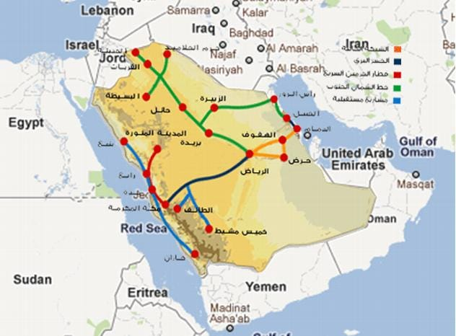](https://substackcdn.com/image/fetch/f_auto,q_auto:good,fl_progressive:steep/https:/substack-post-media.s3.amazonaws.com/public/images/f5d2af64-f984-437e-b0d0-c409a5f4a8f7_632x466.jpeg)](https://substackcdn.com/image/fetch/f_auto,q_auto:good,fl_progressive:steep/https%3A%2F%2Fsubstack-post-media.s3.amazonaws.com%2Fpublic%2Fimages%2Ff5d2af64-f984-437e-b0d0-c409a5f4a8f7_632x466.jpeg" \t "_blank)

Unlike decades of Anglo-American promises which treat Arab participants like disposable temporary interests, the China-Russia alliance contains tangible, measurable benefits, like security and development for all participants.

### ****An Alternative To The ‘Rules-Based International Order’****

While the US wasted the past decade imposing sanctions and punishments on nations, institutions, and individuals unaccepting of its global hegemony, China was patiently recruiting West Asian and African states to the BRI: a whopping [20 Arab nations](https://risingtidefoundation.net/2022/07/02/favorable-winds-from-china-how-the-bri-is-transforming-west-asia/) and [46 African nations are taking part today](https://youtu.be/DFPuEc3CTvo?si=uXGn1iBmzZAT3xp2).  
  
NATO-member **Turkey** has also been on the receiving end of Washington’s punishments, and has begun to view China as a potential means to a more independent future – one that comes with the financial resources to mitigate the country’s current economic woes and currency fluctuations.

Turkey, Qatar, and Saudi Arabia had once provided vast support for ISIS and Al Qaeda operations across Iraq, Syria, and Afghanistan, primarily through the purchase of ISIS-controlled oil and the supply of extremist fighters, clandestine funding, and arms transfers. Such support has increasingly dried up, leaving ISIS with very little to work outside of [what the CIA provides](https://www.mintpressnews.com/us-support-isis/245868/). China’s brokering of peace deals between Saudi Arabia and its BRICS-partner Iran as well as Saudi Arabia and Yemen (which may become a conduit for massive development as a [connecting point from the Addis Ababa-Djibouti SGR railway via the Bab el Mandeb Strait and into the broader Arabian peninsula](https://matthewehret.substack.com/p/india-russia-iran-eurasias-new-transportation)) is a serious prospect keeping many a geopolitician up at night.

Despite US President Joe Biden [re-affirming military support](https://asiatimes.com/2021/10/biden-pledge-bolsters-allied-syrian-kurd-rebels/) in October for the Kurdish-led Syrian Defense Forces (SDF) occupying north-east Syria, the Kurdish hand has also been overplayed. Many are finally recognizing that the Kurds have been duped into serving as a counter-gang to ISIS, and that promises for a Kurdish state have proved to be as illusory as the dream of Assad’s overthrow.

Erdogan may have tried to walk both worlds for some time, but it has increasingly become clear that Turkey’s only chance for survival rests with Russian military cooperation and China’s BRI (which crosses Turkey in the form of the Middle Corridor), both [of] which demand a **defense of Syria’s sovereignty**.

### Follow my work on Telegram at: T.me/CanadianPatriotPress